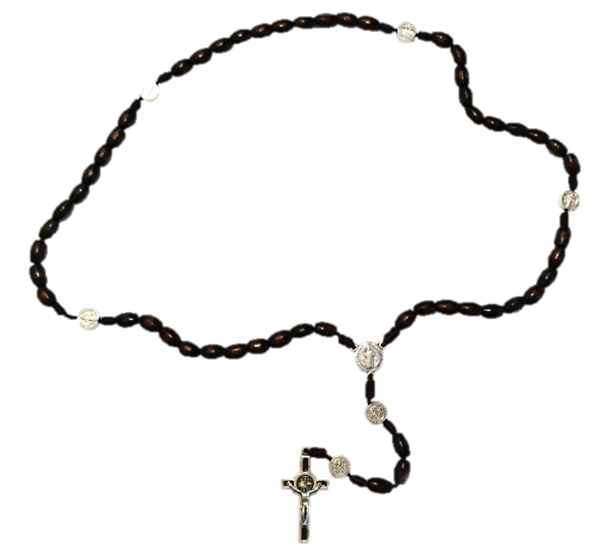


Rosary around Switzerland

Pray for Switzerland and the world
Sunday 3 October 2021 2:30 p.m.
(with Papal, SBK and Episcopal Blessings)

Name of Prayer Site: Church St. Heilige
Location: Anywhere Strasse 00, Zürich 8000
Contact Person: Heidi Müller
Handy/email: 076 622 2019 / Heidi@bluewin.ch

For much more general information about this day go to www.prayschwiiz.ch.

“The Rosary is the weapon for these times.” St. Padre Pio

